FIDDLE

GRADE 1

1. PERFORMANCE: you have a maximum of 4 ½ minutes to play:

One air:

 | Title | Composer | Time-Sig | Type | Source
A1 | Come By the Hills | Traditional | 3/4 | Waltz | Ref. 2
A2 | Morag of Dunvegan | Traditional | 3/4 | Waltz | Ref. 8/9
A3 | The Nameless Lassie | Alex Mackenzie | 4/4 | Air | Ref.8/9
A4 | The Yellow Haired Laddie | Traditional | 4/4 | Air | Ref. 24
A5 | Tuireadh Iain Ruaidh | Traditional | 6/8 | Air | Ref. 6/7
A6 | Will Ye No Come Back Again | Traditional | 4/4 | Air | Ref. 3

One dance tune:

 | Title | Composer | Time-Sig | Type | Source
B1 | Aitken Drum | Traditional | 4/4 | March/Reel | Ref. 2
B2 | Fear a’ Phige | Traditional | 4/4 | Schottische | Ref. 3
B3 | Alasdair an Duin | A. MacDonnachaidh | 4/4 | Reel | Ref. 25
B4 | Marie’s Wedding | Traditional | 4/4 | March | Ref. 2
B5 | Oliver Jack | Traditional | 4/4 | Shetland Reel | Ref. 26
B6 | The Corner House Jig | Andrew Rankine | 6/8 | Jig | Ref. 3
B7 | The Green Hills of Tyrol | PM J. MacLeod | 3/4 | March | Ref. 2

One recently-composed tune:

 | Title | Composer | Time-Sig | Type | Source
C1 | Rocking the Baby | Traditional | 6/8 | Jig | Ref. 26
C2 | Sunset Over Foula | Ronnie Cooper | 3/4 | Waltz | Ref. 27
C3 | The Highlander’s Revenge | Bruce MacGregor | 4/4 | March | Ref. 28
C4 | The Seven Step Polka | Traditional | 4/4 | Polka | Ref. 29
C5 | The Stronsay Wedding | John Mason | 2/4 | Reel | Ref. 2

2. TECHNICAL WORK: played from memory from among the following keys and ranges:

A, D, G majors (one octave)

Any standard fingering is acceptable.

Scales: ascending and descending, with separate bows and two quavers slurred to a bow, as in:

Arpeggios: ascending and descending, with separate bows, as in:

The examiner will request only as many of the above items as needed to form a firm opinion of your ability.

3. QUICK STUDY: Perform EITHER at sight or by ear, at your choice, a short passage in air or waltz time. For example:

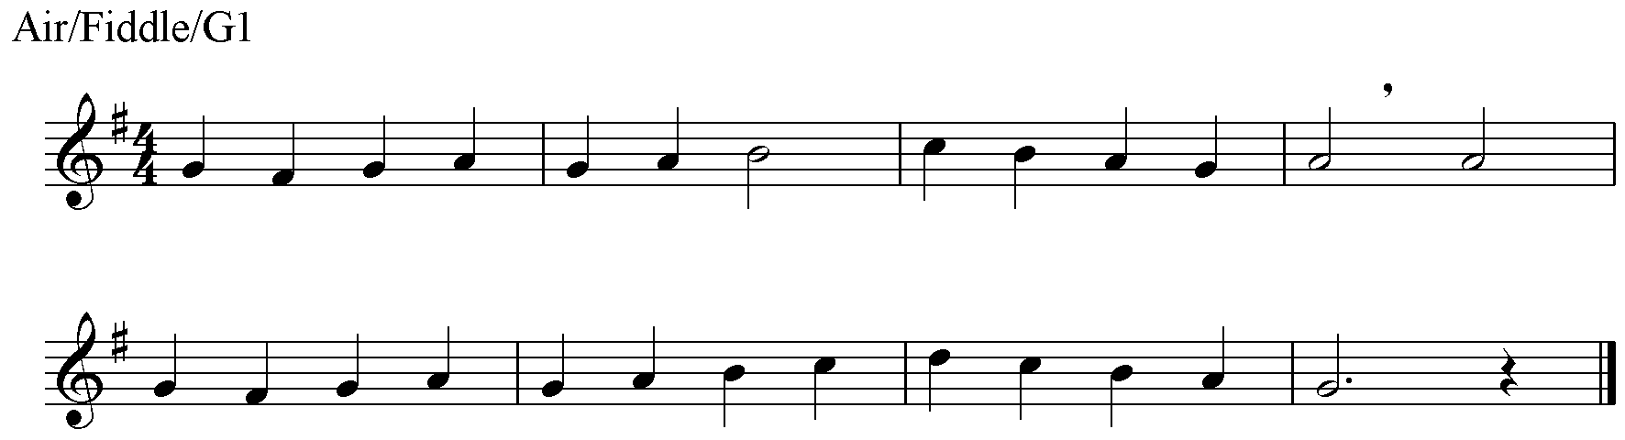

The piece will be in one of the keys covered by the scale requirements at this grade.

*Note – Ear players will only be required to play to the comma.

4. PRACTICAL AND AURAL MUSICIANSHIP FOR THE GRADE

GRADE 2

1. PERFORMANCE: you have a maximum of 6 minutes to play two stand-alone tunes and one set of two tunes chosen from the following categories. At least one tune from each category must be played.

Airs:

 | Title | Composer | Time-Sig | Type | Source
A1 | Cearcall a’ Chuain | Rory MacDonald | 3/4 | Air | Ref. 3
A2 | Fagail Glaschu | Traditional | 3/4 | Waltz | Ref. 24
A3 | Leezie Lindsay | Traditional | 3/4 | Air/Waltz | Ref. 3
A4 | Sarona | J. Scott Skinner | 4/4 | Air | Ref. 30
A5 | The Hills of Lorne | Charles Hunter | 4/4 | Air | Ref. 2
A6 | The Piper’s Weird | J. Scott Skinner | 6/8 | Air | Ref. 30

Dance tunes:

 | Title | Composer | Time-Sig | Type | Source
B1 | Brochan Lom | Traditional | 4/4 | Schottische | Ref. 2
B2 | Clean Pea Srae | Traditional | 4/4 | Reel | Ref. 5
B3 | Donald Blue | Traditional | 4/4 | Reel | Ref. 11
B4 | Edmund McKenzie of Plockton | Andrew Rankine | 6/8 | Jig | Ref. 3
B5 | Far Am Bi Mi Fhin | Traditional | 4/4 | Strathspey | Ref. 31
B6 | Highland Laddie | Traditional | 2/4 | March | Ref. 2
B7 | Highland Whisky | Traditional | 4/4 | Strathspey | Ref. 6/7
B8 | Murdo’s Wedding | Traditional | 4/4 | March | Ref. 5
B9 | Soldiers Joy | Traditional | 4/4 | Reel | Ref. 3
B10 | The Campbeltown Kiltie Ball | J. McLellan | 4/4 | Strathspey | Ref. 8/9
B11 | The Stool of Repentence | Niel Gow | 6/8 | Jig | Ref. 4

Recently –composed tunes:

 | Title | Composer | Time-Sig | Type | Source
C1 | The 51st Highland Division | Donald MacLeod | 4/4 | March | Ref. 10
C2 | Walking on the Moon | Addie Harper | 4/4 | Reel | Ref. 8/9
C3 | The Soup Dragon | Gordon Duncan | 6/8 | Jig | Ref. 32
C4 | Calum’s Road | Donald Shaw | 4/4 | Strathspey | Ref. 33
C5 | The Jewels of the Ocean | Allan MacDonald | ¾ | Waltz | Ref. 24
C6 | The Starry Nights of Shetland | Traditional | 3/4 | Waltz | Ref. 5
C7 | Da Slockit Light | Tom Anderson | 4/4 | Air | Ref. 5

2. TECHNICAL WORK: played from memory from among the following keys and ranges:

A, G majors (two octaves)
D major; G, A, E minors (one octave)

Any standard fingering is acceptable.

Scales: ascending and descending, with separate bows and two quavers slurred to a bow, as in:

Arpeggios: ascending and descending, with separate bows only, as in:
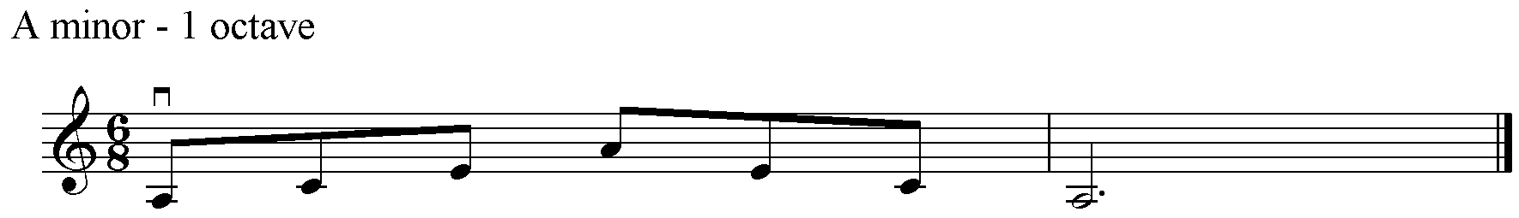

Scales in a minor key may be played in the melodic, harmonic or natural minor, at the candidate’s choice.

Rhythmic Scales:

Candidates will be asked to perform a one octave version of a major scale selected by the examiner to the following rhythm – a crotchet and two quavers on each degree of the scale, as in:

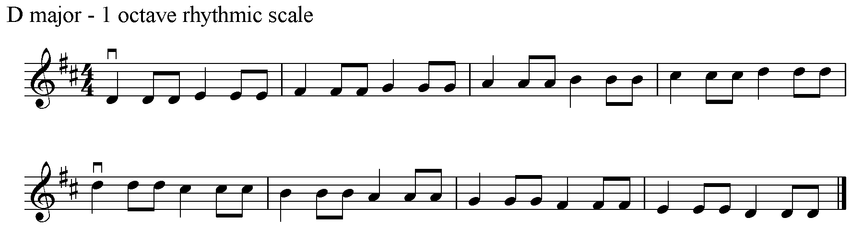

The examiner will request only as many of the above items as needed to form a firm opinion of your ability.

3. QUICK STUDY: Perform EITHER at sight or by ear, at your choice, a short passage in air, waltz or march time. For example:

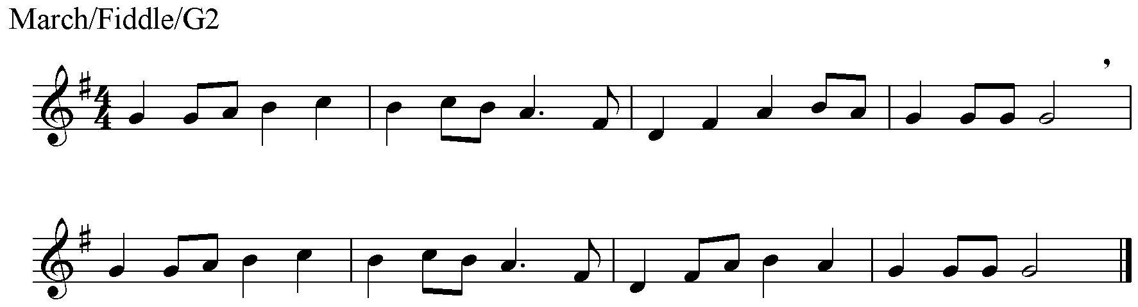

The piece will be in one of the keys covered by the scale requirements up to and including this grade.

*Note – Ear players will only be required to play to the comma.

4. PRACTICAL AND AURAL MUSICIANSHIP FOR THE GRADE

GRADE 3

1. PERFORMANCE: you have a maximum of 6 minutes to play two stand-alone tunes and one set of two tunes chosen from the following categories. At least one tune from each category must be played.

Airs:

 | Title | Composer | Time-Sig | Type | Source
A1 | Major Graham of Inchbrakie | Niel Gow | 4/4 | Air | Ref. 34
A2 | Mrs Jamieson’s Favourite | C. Grant | 6/8 | Air | Ref. 3
A3 | The Flower of the Quern | J. Scott Skinner | 4/4 | Air | Ref. 6/7
A4 | The Mist-Covered Mountains | Traditional | 3/4 | Air | Ref. 6/7
A5 | The Love of the Isles | Willie Hunter | 4/4 | Air | Ref. 35
A6 | The Pearl | Phil Cunningham | 4/4 | Air | Ref. 36
A7 | Helen N. Robertson | A. Scott Robertson | 3/4 | Air | Ref. 1

Dance tunes:

 | Title | Composer | Time-Sig | Type | Source
B1 | The Boys of Bluehill | Traditional | 4/4 | Hornpipe | Ref. 3
B2 | Dr. Morrison’s Seven Thistles | J. Scott Skinner | 4/4 | March | Ref. 11
B3 | The Flowers of Edinburgh | Traditional | 4/4 | Reel | Ref. 24
B4 | The Heather Hills | Traditional | 6/8 | Jig | Ref. 5
B5 | Jessie Smith | Traditional | 4/4 | Strathspey | Ref. 8/9
B6 | Willafjord | Traditional | 4/4 | Reel | Ref. 11
B7 | The Lad with the Plaidie | Traditional | 4/4 | Strathsepy | Ref. 3
B8 | The Shores of Loch Bee | Traditional | 4/4 | March | Ref. 10
B9 | The Pibroch of Domhnall Dubh | Traditional | 6/8 | Jig | Ref. 6/7
B10 | The Battle of Waterloo | Traditional | 4/4 | March | Ref. 6/7

Recently-composed tunes:

 | Title | Composer | Time-Sig | Type | Source
C1 | Bob Hobkirk’s Polka | Bob Hobkirk | 4/4 | Polka | Ref. 37
C2 | Gibby Gray | Steven Spence | 2/4 | Reel | Ref. 38
C3 | Hamnataing | Chris Stout | 4/4 | Air | Ref. 39
C4 | John Keith Laing | Addie Harper | 4/4 | Reel | Ref. 13
C5 | The Fiddler | Donald MacLeod | 4/4 | Strathspey | Ref. 13
C6 | Marni Swanson of the Grey Coast | Andy Thorburn | 6/4 | Air | Ref. 28
C7 | The Hut on Staffin Island | Phil Cunningham | 4/4 | March | Ref. 4
C8 | Jim Anderson’s Delight | Ronnie Cooper | 6/8 | Jig | Ref. 11

2. TECHNICAL WORK: played from memory from among the following keys and ranges:

A, D, G majors; G, A minor (two octaves)
C, F, Bb majors; E, B, D minors (one octave)

Any standard fingering is acceptable.

Scales: ascending and descending, with separate bows and two quavers slurred to a bow, as in Grade 2.

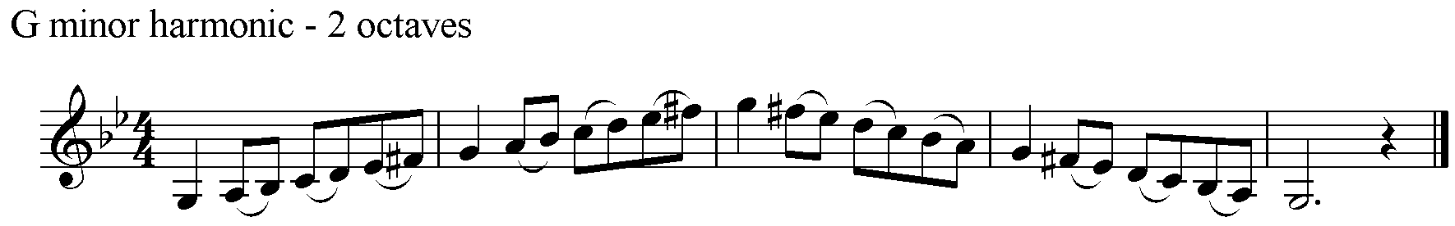

Arpeggios: ascending and descending, with separate bows and three notes slurred to a bow, as in:

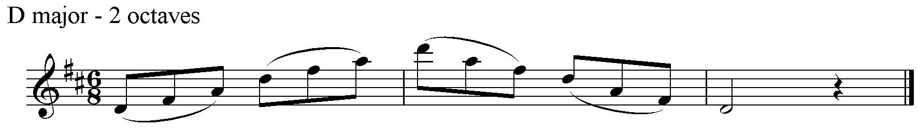

Scales in a minor key may be played in the melodic, harmonic minor or natural minor, at the candidate’s choice.

Rhythmic Scales:

Candidates will be asked to perform a one octave version of a major scale selected by the examiner from the following rhythms – a crotchet and two quavers on each degree of the scale, as in:

OR a triplet on each degree of the scale (jig rhythm), as in:

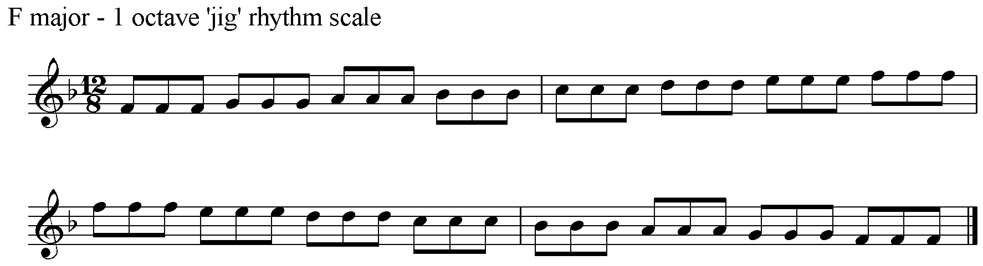

The examiner will request only as many of the above items as needed to form a firm opinion of your ability.

3. QUICK STUDY: Perform EITHER at sight or by ear, at your choice, a short passage in waltz, march or jig time. For example:

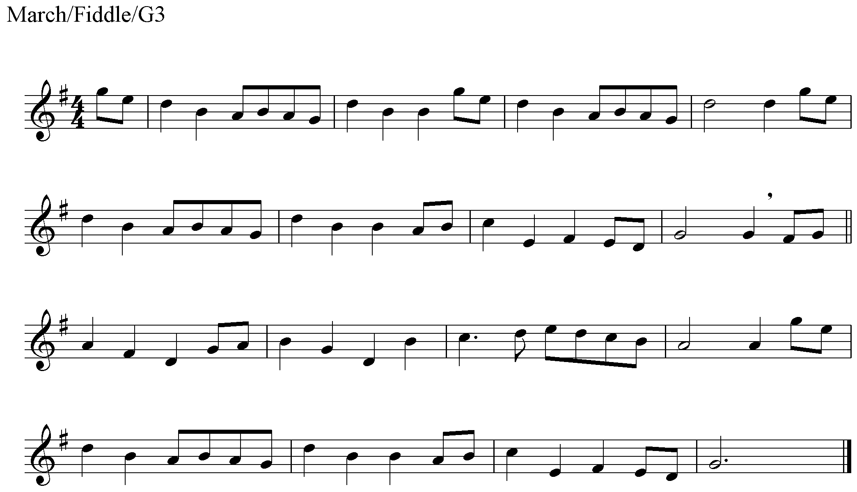

The piece will be in one of the keys covered by the scale requirements up to and including this grade.

*Note – Ear players will only be required to play to the comma.

4. PRACTICAL AND AURAL MUSICIANSHIP FOR THE GRADE

GRADE 4

1. PERFORMANCE: you have a maximum of 9 minutes to play two stand-alone tunes and one set of three tunes chosen from the following categories. At least one tune from each category must be played.

Airs:

 | Title | Composer | Time-Sig | Type | Source
A1 | Coilsfield House | Nathaniel Gow | 4/4 | Air | Ref. 40
A2 | Da Day Dawn | Traditional | 4/4 | Air | Ref. 18
A3 | Lament for the Death of the Rev. Archie Beaton | John Mason | 4/4 | Air | Ref. 6/7
A4 | Sitting in the Stern of a Boat | Rev. W. MacLeod | 4/4 | Air | Ref. 6/7
A5 | Mairi Bhan Og | Traditional | 4/4 | Air | Ref. 41
A6 | Cumha MhicCriomain | Traditional | 4/4 | Air | Ref. 18
A7 | Margaret Ann Robertson | Frank Jamieson | 3/4 | Air | Ref. 10
A8 | Mary Scott Flower of Yarrow | Traditional | 3/4 | Air | Ref. 42
A9 | Hector the Hero | J. Scott Skinner | 6/8 | Air | Ref. 30

Dance tunes:

 | Title | Composer | Time-Sig | Type | Source
B1 | Da Gusiers March | G Stove | 4/4 | March | Ref. 10
B2 | The Iron Man | J. Scott Skinner | 4/4 | Strathspey | Ref. 8/9
B3 | Donald MacLean’s Farewell to Oban | Archibald MacNeil | 2/4 | March | Ref. 10
B4 | Donald MacLeod’s Reel | Traditional | 4/4 | Reel | Ref. 8/9
B5 | High Road to Linton | Traditional | 4/4 | Reel | Ref. 6/7
B6 | Jig of Slurs | G. S. MacLennan | 6/8 | Jig | Ref. 17
B7 | Mackenzie Hay | J. Scott Skinner | 4/4 | Strathspey | Ref. 6/7
B8 | Stirling Castle | Traditional | 4/4 | Strathspey | Ref. 10
B9 | Scott Skinner’s Compliments to Dr MacDonald | J. Scott Skinner | 4/4 | March | Ref. 30
B10 | Wha’ll Be King But Charlie | Traditional | 6/8 | Jig | Ref. 41
B11 | The Brolum | C Bannatyne | 4/4 | Reel | Ref. 17
B12 | Kenny Gillies of Portnalong | P MacFarquhar | 6/8 | Jig | Ref. 8/9

Recently-composed tunes:

 | Title | Composer | Time-Sig | Type | Source
C1 | Frank’s Reel | John McCusker | 4/4 | Reel | Ref. 28
C2 | Gillian’s Waltz | Gordon Gunn | 3/4 | Waltz | Ref. 43
C3 | Itchy Fingers | unknown | 4/4 | Reel | Ref. 12
C4 | Leaving Stoer | Ivan Drever | 4/4 | Air | Ref. 17
C5 | Millbrae | Ronnie Cooper | 4/4 | Reel | Ref. 11
C6 | Simon Thoumire’s Jig | John McCusker | 6/8 | Jig | Ref. 28
C7 | Spootiskerry | Samuel I R Burns | 4/4 | Reel | Ref. 12
C8 | The Sleeping Tune | Gordon Duncan | 4/4 | Air | Ref. 32
C9 | The Westcoaster | Angus Grant | 4/4 | Hornpipe | Ref. 44

2. TECHNICAL WORK: played from memory from among the following keys and ranges:

A, Bb, C, D, G majors; A, B, D, G minors (two octaves)
Eb, E majors; C minor (one octave)

Any standard fingering is acceptable.

Scales: ascending and descending, with separate bows and two beats slurred to a bow, as in:

Arpeggios: ascending and descending, with separate bows and three notes slurred to a bow, as in Grade 3.

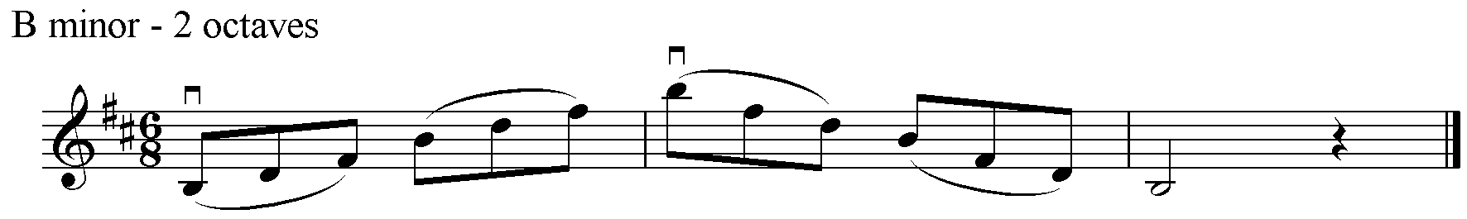

Scales in a minor key may be played in the melodic, harmonic or natural minor, at the candidate’s choice.

Rhythmic Scales:

Candidates will be asked to perform a one octave version of a major scale selected by the examiner from the following rhythms – a triplet on each degree of the scale (jig rhythm), as in:

OR a dotted quaver/semi quaver rhythm on each degree of the scale as in:

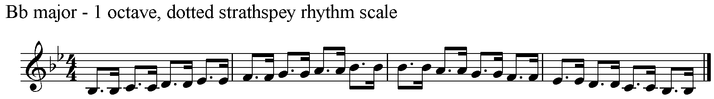

OR a semi quaver/dotted quaver on each degree of the scale as in:

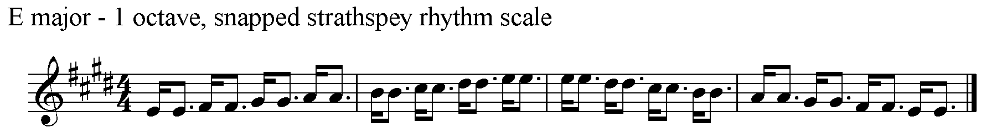

The examiner will request only as many of the above items as needed to form a firm opinion of your ability.

3. QUICK STUDY: Perform EITHER at sight or by ear, at your choice, a short passage in march, jig or strathspey time. For example:

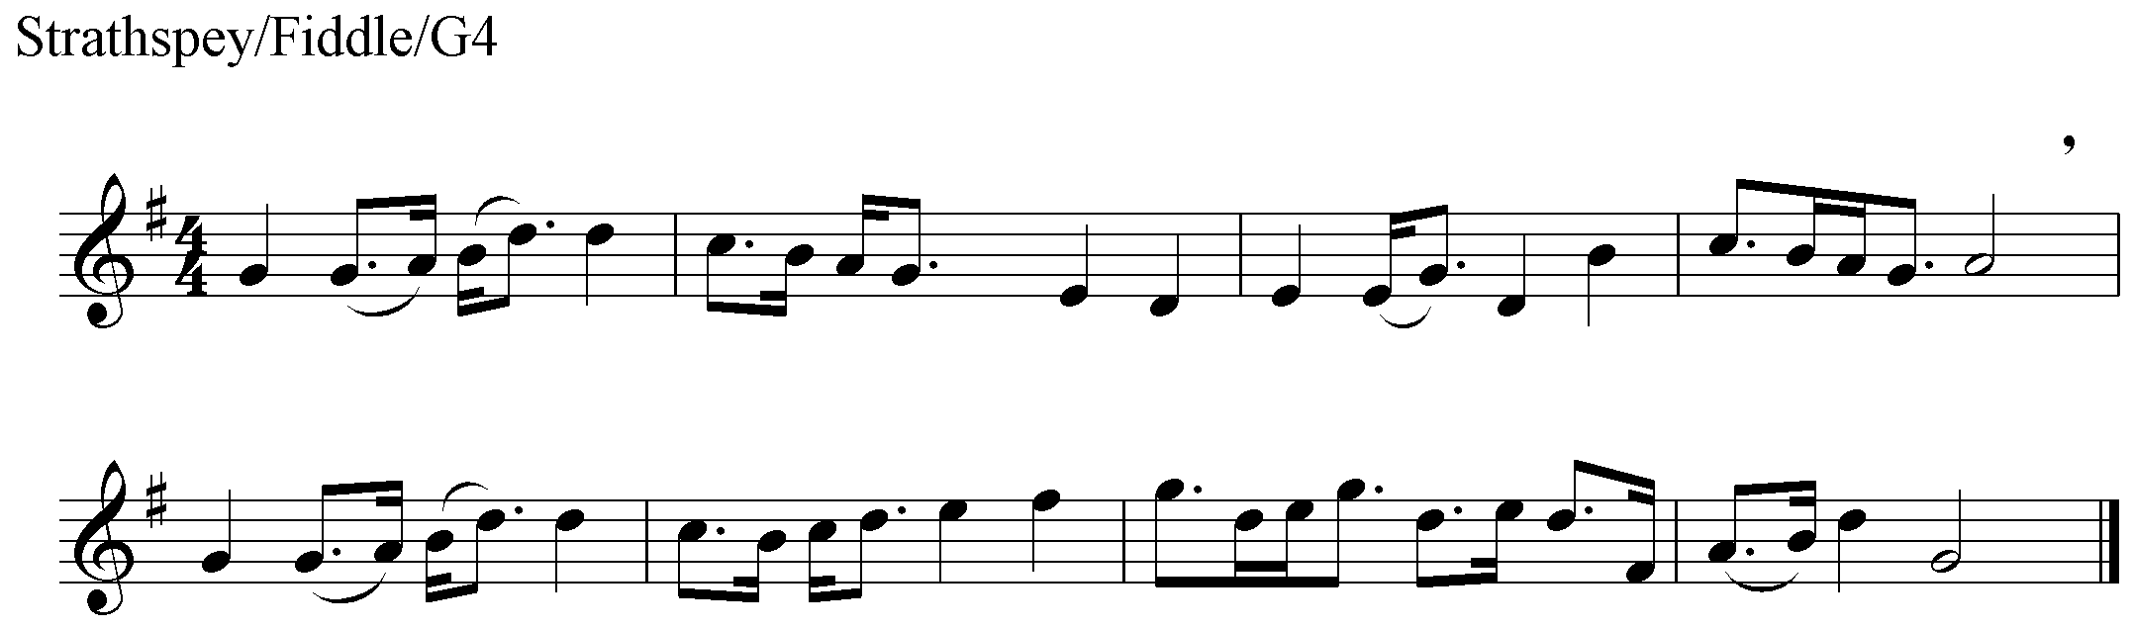

The piece will be in one of the keys covered by the scale requirements up to and including this grade.

*Note – Ear players will only be required to play to the comma.

4. PRACTICAL AND AURAL MUSICIANSHIP FOR THE GRADE

GRADE 5

1. PERFORMANCE: you have a maximum of 9 minutes to play two stand-alone tunes and one set of three tunes chosen from the following categories. At least one tune from each category must be played.

Airs:

 | Tune Title | Composer | Time-Sig | Type | Source
A1 | Bovaglie’s Plaid | J. Scott Skinner | 4/4 | Air | Ref. 30
A2 | Chapel Keithack | Wm Marshall | 3/4 | Air | Ref. 24
A3 | Eilean Aigeis | Traditional | 3/4 | Air | Ref. 41
A4 | Niel Gow’s Lament for the Death of His Second Wife | Niel Gow | 6/8 | Air | Ref. 6/7
A5 | The Emigrant’s Farewell (Ho Chan Eil Mulad Oirnn) | Traditional | 4/4 | Air (slow strathspey) | Ref. 41
A6 | Miss Graham of Inchbrakie | Nath. Gow | 4/4 | Air | Ref. 45
A7 | Roslin Castle | Traditional | 4/4 | Air | Ref. 46
A8 | The Coleburn | Wm MacPherson | 4/4 | Air | Ref. 47

Dance tunes:

 | Tune Title | Composer | Time-Sig | Type | Source
B1 | Ben Gullion | R Fleming | 6/8 | March | Ref 10
B2 | Earl Grey | James Hill | 4/4 | Strathspey | Ref. 6/7
B3 | John MacNeil | Peter Milne | 4/4 | Reel | Ref. 48
B4 | Miss Sally Hunter of Thurston | Nath. Gow | 6/8 | Jig | Ref. 26
B5 | Miss Shepherd | J. Scott Skinner | 4/4 | Reel | Ref. 30
B6 | John Stephen of Chance Inn | Angus Fitchet | 4/4 | Strathspey | Ref. 8/9
B7 | The Tushkar | Ronnie Cooper | 4/4 | Reel | Ref. 12
B8 | The Braes of Castle Grant | D. MacDonald | 2/4 | March | Ref. 8/9
B9 | The Orkney Polka | Traditional | 4/4 | Polka | Ref. 18
B10 | The Sands of Murness | Frank Jamieson | 4/4 | Strathspey | Ref. 13
B11 | The Warlocks | Traditional | 4/4 | Strathspey | Ref. 10
B12 | Willie’s Auld Trews | Traditional | 4/4 | Slow Reel | Ref. 41
B13 | The Sprig Of Ivy | B. Seton | 2/4 | March | Ref 9

Recently-composed tunes:

 | Tune Title | Composer | Time-Sig | Type | Source
C1 | Calliope House | Dave Richardson | 6/8 | Jig | Ref. 11
C2 | The Easy Club Reel | Jim Sutherland | 4/4 | Reel | Ref. 49
C3 | Liz Kane | Alistair McCulloch | 4/4 | Reel | Ref. 50
C4 | Garry Porch of Avernish | Adam Sutherland | 4/4 | Strathspey | Ref. 28
C5 | Leaving Lerwick Harbour | Willie Hunter | 4/4 | Air | Ref. 35
C6 | The Tongadale Reel | Farquhar MacDonald | 2/4 | Reel | Ref. 13
C7 | The Quiet Man | Jim Sutherland | 4/4 | Strathspey | Ref. 49
C8 | Dram Behind the Curtain | Mairearad Green | 6/8 | Jig | Ref. 51
C9 | Seud nan Ceud Bliadhna | Phil Cunningham | 2/4 | March | Ref. 13
C10 | Maggie West’s Waltz | Mairearad Green | ¾ | Waltz | Ref. 51

2. TECHNICAL WORK: played from memory from among the following keys and ranges:

A, Bb, C, D, E, Eb, G majors; A, B, C, D, E, G minors (two octaves)

Any standard fingering is acceptable.

Scales: ascending and descending, with separate bows and two beats slurred to a bow, as in Grade 4.

Arpeggios: ascending and descending, with separate bows and six notes slurred to a bow, as in:

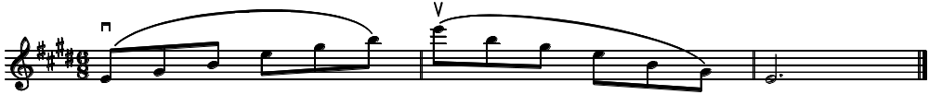

Scales in a minor key may be played in the melodic, harmonic or natural minor, at the candidate’s choice.

Rhythmic Scales:

Candidates will be asked to perform a one octave version of a major scale selected by the examiner from the following rhythms – a dotted quaver/semi quaver rhythm on each degree of the scale as in:

OR a semi quaver/dotted quaver on each degree of the scale as in:

OR alternating between dotted strathspey rhythm and snapped strathspey rhythm on each degree of the scale (combined dotted/snapped strathspey rhythm), as in:

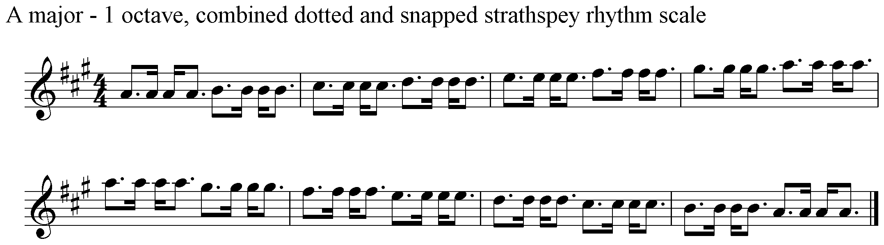

OR a ‘birl’ and crotchet on each degree of the scale, (birl scale), as in:

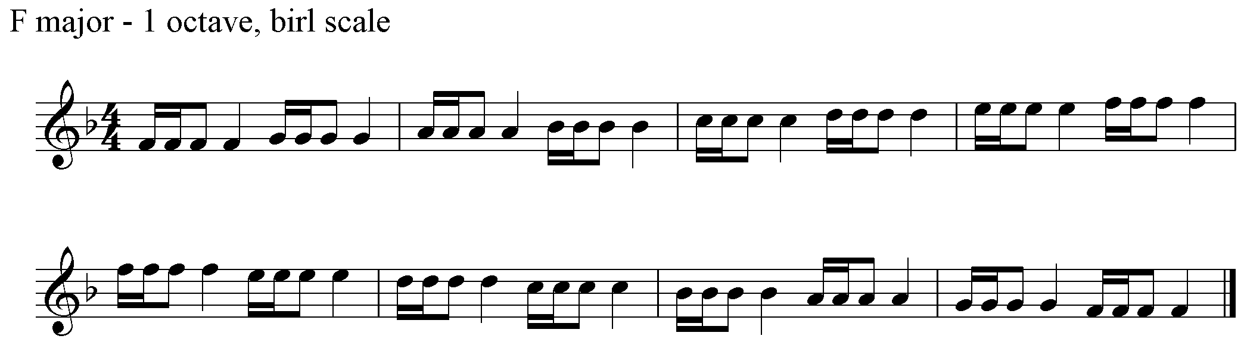

The examiner will request only as many of the above items as needed to form a firm opinion of your ability.

3. QUICK STUDY: Perform EITHER at sight or by ear, at your choice, a short passage in jig, strathspey or reel time. For example:

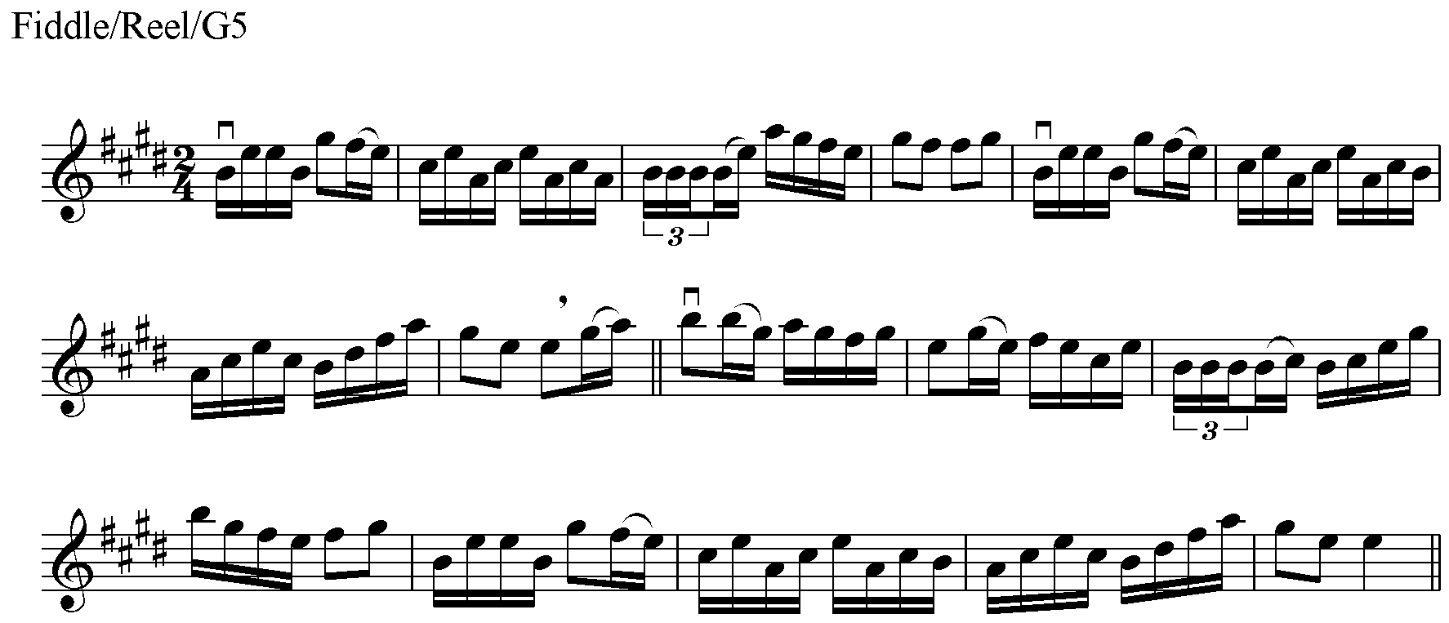

The piece will be in one of the keys covered by the scale requirements up to and including this grade.

*Note – Ear players will only be required to play to the comma.

4. PRACTICAL AND AURAL MUSICIANSHIP FOR THE GRADE

References for tunes listed in the fiddle syllabus

Reference | Title | Publisher/Edition/Year
Ref 1 | Fiddle Music of Scotland | Hardie Press: 1988
Ref 2 | Scottish Ceilidh Collection for Fiddlers, Book 1 | Harpstring House: 1993
Ref 3 | Scottish Ceilidh Collection for Fiddlers, Book 2 | Harpstring House: 1990
Ref 4 | Scottish Ceilidh Collection for Fiddlers, Book 3 | Harpstring House: 1993
Ref 5 | Scottish Ceilidh Collection for Fiddlers, Book 4 | Harpstring House: 1998
Ref 6 | Ceòl na Fìdhle: Highland Tunes for the Fiddle, Book 1 | Harpstring House: 1985/1988
Ref 7 | Ceòl na Fìdhle: Highland Tunes for the Fiddle, Book 2 | Harpstring House: 1988/1993
Ref 8 | Ceòl na Fìdhle: Highland Tunes for the Fiddle, Book 3 | Harpstring House: 1988/1995
Ref 9 | Ceòl na Fìdhle: Highland Tunes for the Fiddle, Book 4 | Harpstring House: 1991
Ref 10 | Ceòl na Fìdhle: Highland Tunes for the Fiddle, Volumes 5 & 6 | Harpstring House: 2000
Ref 11 | Ho-ro-gheallaidh: Session Tunes for Scottish Fiddlers, Book 1 | Harpstring House: 1999
Ref 12 | Ho-ro-gheallaidh: Session Tunes for Scottish Fiddlers, Book 2 | Harpstring House: 1999
Ref 13 | Cruinn Còmhla: The Well-Travelled Fiddler's Session Collection | Harpstring House: 1995
Ref 14 | The Nineties Collection: New Scottish Tunes in Traditional Style | Saltire Music: 1995
Ref 15 | The Jim Johnstone Collection of Original Compositions for Accordion and Fiddle | Deeay Music: 1996
Ref 16 | The Scots Fiddle vol 1 | Lochar Publishing: 1991
Ref 17 | Ceòl nam Fèis, Book 2 | Fèisean nan Gàidheal: 2000
Ref 18 | Traditional Scottish Fiddling | Harpstring House
Ref 19 | Available to order from Taigh na Teud; please see www.scotlandsmusic.com. | N/a
Ref 20 | Ceol nam Feis Book 1 | Feisean nan Gaidheal: 1996
Ref 21 | The Waves of Sound | Deeay Music: 2002
Ref 22 | The Tom Anderson Collection Vol 1 by Tom Anderson | Hardie Press: 1995
Ref 23 | The Scots Fiddle vol 3: Tunes, Tales and Traditions of the Western Highlands, Hebrides, Orkney and Shetland | NWP: 2004
Ref 24 | Arr. A. McCulloch
Ref 25 | Òrain an Eilein | Harpstring House
Ref 26 | Arr. Taigh na Teud | Harpstring House
Ref 27 | Ronnie Cooper Collection | Shetland Heritage Trust
Ref 28 | Ho-ro-gheallaidh: Session Tunes for Scottish Fiddlers, Book 3 | Harpstring House: 2009
Ref 29 | The Scottish Folk Fiddle Tutor | Harpstring House
Ref 30 | The Scottish Violinist | Harpstring House
Ref 31 | Tog Fonn | Harpstring House
Ref 32 | Gordon Duncan Collection | Grian Music
Ref 33 | Copyright Donald Shaw
Ref 34 | Traditional Tunes for Two Fiddlers Book 2 | Harpstring House
Ref 35 | The Music of Willie Hunter | Shetland Heritage Trust
Ref 36 | The Cunningham Collection | Phil Cunningham
Ref 37 | Bob Hobkirk | Bob Hobkirk
Ref 38 | Spencie’s Tunes | Steven Spence
Ref 39 | Chris Stout Collection Vol. 1 | Chris Stout
Ref 40 | The Scottish Folk Fiddle Third Position Book | Harpstring House
Ref 41 | The Airs and Melodies Peculiar to the Highlands of Scotland and The Isles (The Simon Fraser Collection)
Ref 42 | Tunes, Tales & Traditions of the Lothians, Borders and Ayrshire | J Murray Neil
Ref 43 | Gordon Gunn | Gordon Gunn
Ref 44 | The Glengarry Collection | Angus Grant
Ref 45 | The Beauties of the North | Jean Ann Callander
Ref 46 | The James Oswald Collection | Jean Ann Callander
Ref 47 | Willie MacPherson The Elgin Fiddler | Catriona MacPherson
Ref 48 | The Elphinstone Collection by Paul Anderson | Harpstring House
Ref 49 | Copyright Jim Sutherland
Ref 50 | The Alistair McCulloch Collection | Fellsongs
Ref 51 | Passing Places | Mairearad Green

